AI-Powered Image Classification System

Objective:
To design, train, and evaluate an AI model capable of classifying images into multiple categories using deep learning techniques. This project will assess the candidate’s understanding of data preprocessing, model architecture, and deployment readiness.

1.Document Types:
An image classification system is able to manage various kinds of documents for the purpose of identifying and possibly classifying them based on their visual structure. The key document types consist of scanned paper documents, forms, handwritten notes, printed documents, or any other type, each creating a distinct array of visual and structural attributes for classification.
Dataset taken: Dataset taken from datasets.cifar10.load_data()

2. Results and future improvement :
- The accuracy of predictions can be further improved through the use of two-stream classifiers, which extract information from both text and image features, enhancing predictions in datasets characterized by high variability in structure.
- Evaluating these systems generally uses accuracy, precision, recall, a F1 score, and confusion matrices, demonstrating excellence on well-annotated benchmark datasets.
- Furthermore, improvements in model optimization and algorithms lead to efficient inference and, in many cases, real-time classification capable of running on edge devices - such as mobile phone - for data capture in the field.
Code :
Code:
import tensorflow as tf
from tensorflow.keras import datasets, layers, models
import matplotlib.pyplot as plt
import numpy as np
#dataset:
(X_train, y_train), (X_test, y_test) = datasets.cifar10.load_data()
X_train.shape
X_test.shape
X_train[1]
plt.imshow(X_train[1])
y_train[:5]
y_train = y_train.reshape(-1, )
y_train[:5]
classes = ["airplane","automobile","bird","cat","deer","dog","frog","horse","ship","truck"]
classes[9]
class_names = ["airplane","automobile","bird","cat","deer","dog","frog","horse","ship","truck"]

def plot_sample(X, y, index):
plt.figure(figsize=(5, 5))
plt.imshow(X[index])
plt.title(f"Label: {class_names[y[index]]}")
plt.axis('off')
plt.show()
plot_sample(X_train, y_train, 0)
plot_sample(X_train, y_train, 1)
X_train = X_train / 255.0
X_test = X_test / 255.0

#implementing Ann:
ann = models.Sequential([
layers.Flatten(input_shape=(32, 32, 3)),
layers.Dense(3000, activation='relu'),
layers.Dense(1000, activation='relu'),
layers.Dense(10, activation='sigmoid')
])
ann.compile(optimizer='SGD' ,
loss='sparse_categorical_crossentropy',
metrics=['accuracy'])
ann.fit(X_train, y_train, epochs=15)
ann.evaluate(X_test, y_test)
from sklearn.metrics import confusion_matrix, classification_report
import numpy as np
y_pred = ann.predict(X_test)
y_pred_classes = [np.argmax(element) for element in y_pred]
print("Classification Report: \n", classification_report(y_test, y_pred_classes))
#Implementing CNN:
cnn = models.Sequential([
layers.Conv2D(filters=32, kernel_size=(3, 3), activation='relu', input_shape=(32, 32, 3)),
layers.MaxPooling2D((2,2)),
layers.Conv2D(filters=64, kernel_size=(3, 3), activation='relu'),
layers.MaxPooling2D((2,2)),
layers.Flatten(),
layers.Dense(64, activation='relu'),
layers.Dense(10, activation='softmax'),
])

cnn = models.Sequential([
layers.Flatten(),
layers.Dense(64, activation='relu'),
layers.Dense(10, activation='softmax'),
])
(0.45) / (0.45+0.67)
(0.67) / (0.45+0.67)
from tensorflow.keras.models import Sequential
from tensorflow.keras.layers import Input, Conv2D, Flatten, Dense
# Define model
model = Sequential([
Input(shape=(28, 28, 1)),
Conv2D(32, (3, 3), activation='relu'),
Flatten(),
Dense(10, activation='softmax')
])

cnn.compile(optimizer='adam',
loss='sparse_categorical_crossentropy',
metrics=['accuracy'])

cnn.fit(X_train, y_train, epochs=25)
#Accuracy:
70% accuracy got.

cnn.evaluate(X_test, y_test)
y_test = y_test.reshape(-1, )
y_test[:5]
plot_sample(X_test, y_test, 1)
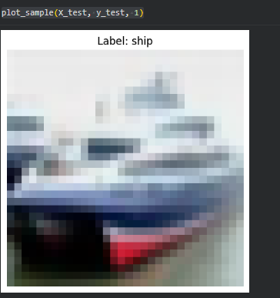
y_pred = cnn.predict(X_test)
y_pred[:5]
y_classes = [np.argmax(element) for element in y_pred]
y_classes[:5]
y_test[:5]
class_names = ['airplane","automobile","bird","cat","deer","dog","frog","horse","ship","truck']
class_names = ['airplane', 'automobile', 'bird', 'cat', 'deer',
'dog', 'frog', 'horse', 'ship', 'truck']

def plot_sample(X, y, index):
plt.figure(figsize=(5, 5))
plt.imshow(X[index], cmap='gray')
label_index = int(y[index])
plt.title(f"Label: {class_names[label_index]}")
plt.axis('off')
plt.show()

plot_sample(X_test, y_test, 3)
classes[y_classes[3]]
print("Classification Report: \n", classification_report(y_test, y_classes))

#Classification Report:
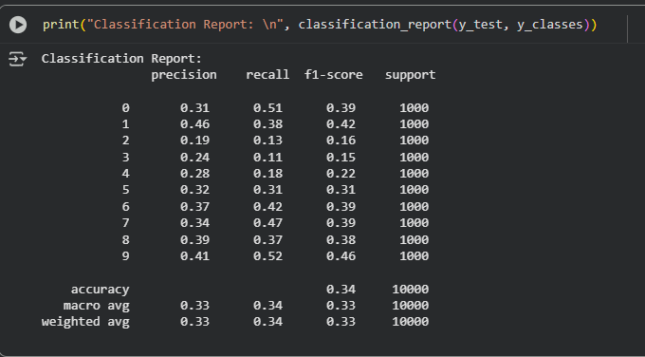
plot_sample(X_test, y_test, 3)
#Final Test and Output:
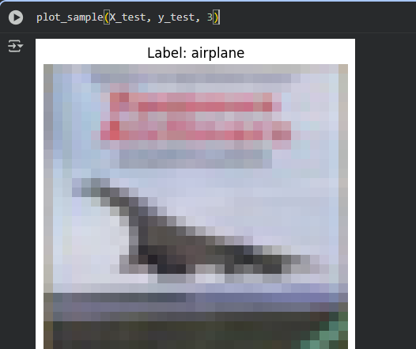

Name: B.sabsepyara
Email: pyarasabse@gmail.com
Website: www.flikt.store

